# 

# Build Instructions: TOMScanner

A technological way to solve shoping problems for the visually impaired people.

Developed by: Angel Marinov, Radoslav Mandev and Mihail Tsvetogorov

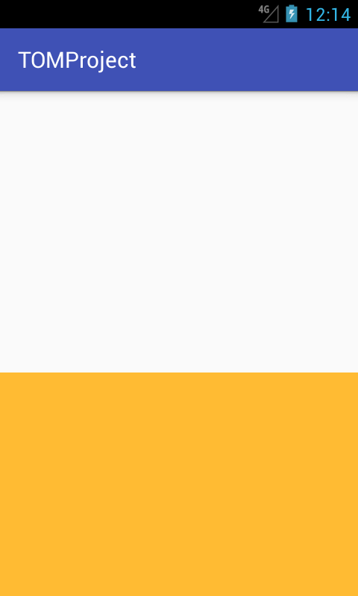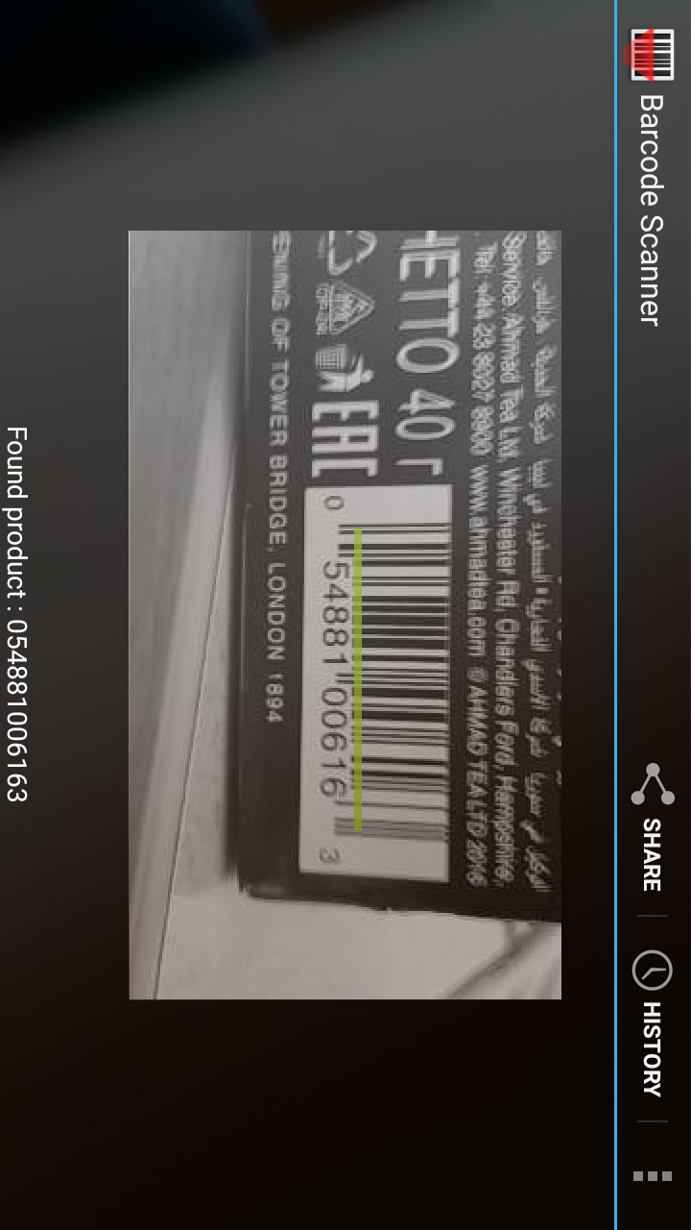

Approximate Cost: $0.0

Time required us to make it: 35 hours

Time required to install: 10 minutes

# General Warnings and Cautions

* **Read through entire manual before attempting to build this device.**
* **Do not attempt a step if you are unsure of what you are doing.** Certain steps in this manual require experience with fabrication tools. <<General Warning>>. For assistance or clarification of any step, contact mihailtsvetogorov@gmail.com.

# User Assistance

For any questions regarding the assembly, operation, or specifications of this device, please this [website](https://www.dropbox.com/sh/pkr5p6ln9zpa9oq/AACDIuXVglm-KDLW5qbbChvqa?dl=0). You can also contact send an email to mihailtsvetogorov@gmail.com or call +359 876 606 152.

# Icon Glossary

The following icons may be used throughout this manual—each with its own purpose.

* **Caution:** The caution icon is used to signify whenever someone attempting the procedure may injure themselves or damage their equipment.
* **Note:** The note icon is used to signify useful bits of information that complement the instructions.
* **Reminder:** The reminder icon is used to provide information for after the procedure is completed, such as tips for disassembly.

# Purpose of Device:

The project includes a mobile phone application developed for the need-knower Plamena Yankova. She is visually challenged, 32-year-old woman. A major problem for her, in her day-to-day activities, is recognizing products while shopping, and more specifically reading a product’s name and description. This is either due to the size or the complexity of the fonts used.

# Physical Description:

The project is based on an Android application. Android was chosen as one of the most accessible and popular platforms. It was also the platform used by Plamena. The usage of smart phone allowed a flexible design where all of the required hardware was already in the device itself.

# History of Development:

This project started in TOM Bulgaria 2017 (second edition carried in TU-Varna). The event took place throughout the 10/12/2017 and 10/15/2017. The first meeting of the team took place at 09/30/2017 during the first gathering of the TOM organization team. Later on, meetings with the need-knower were carried out. During the meetings and at the first day of the Makeathon a decision was reached where an Android application with the following specifications was to be developed: (1) The application would use the camera of the smart phone to scan barcodes; (2) Based on the unique number extracted from the barcode the product will be recognized using internet query; (3) The name of the product will then be displayed on the screen of the smart phone with a font large and clear enough to be read by Plamena, it will be also accessible for text-to-speech conversion.

# Bill of Materials – the project requires a smart phone that uses Android

# Tools required if you want to edit the code:

* PC
* Android Studio
* USB cable

# arts Inventory: None

# Parts Inventory: None

# Step 1

## Parts and Tools Used In This Step:

* PC

## Instructions

* Go to the Dropbox link - https://goo.gl/kKw2s5
* Download the .APK/Source Project
* If installing the .APK, remember to enable the installation from unknown sources (if only using the app – skip step 2)

# Step 2

## Parts and Tools Used In This Step:

* Android Studio (will be referred to as AS)
* USB Cable

## Instructions

* Open the source project in AS
* Modify the code
* Enter the “Developer Options” of your phone and enable “USB Debugging” so you can debug and test the app on your phone (NB)